**Creating a Sprite**

Know the difference between a sprite and a sprite sheet!

1. Go to <https://www.piskelapp.com/>

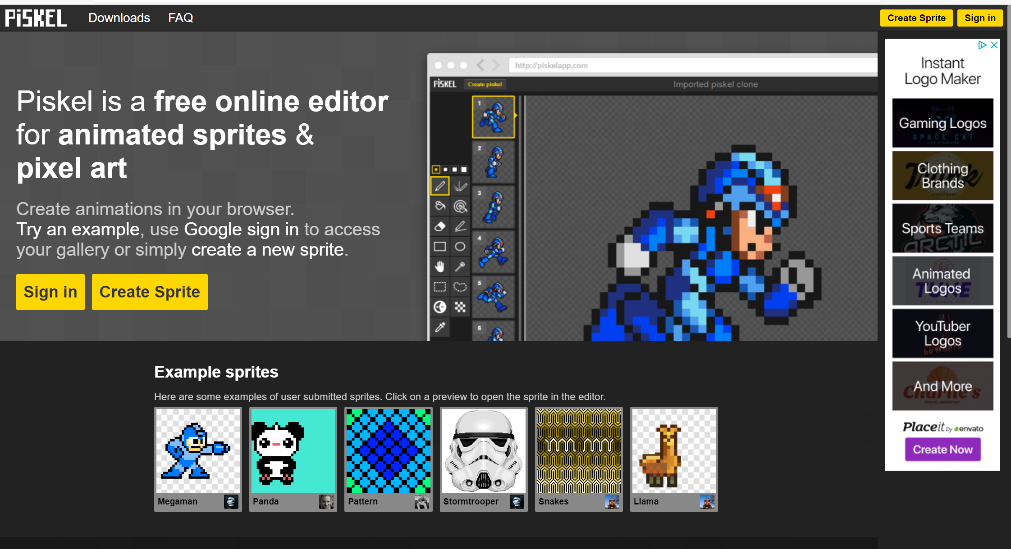

1. Sign in with a Google Account.
2. Choose create sprite

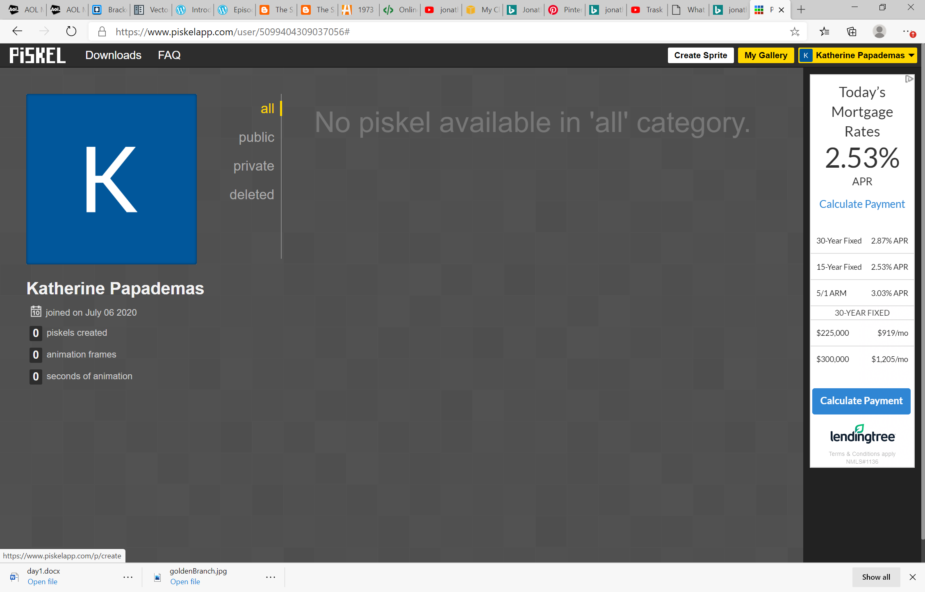

1. The screen should appear as …

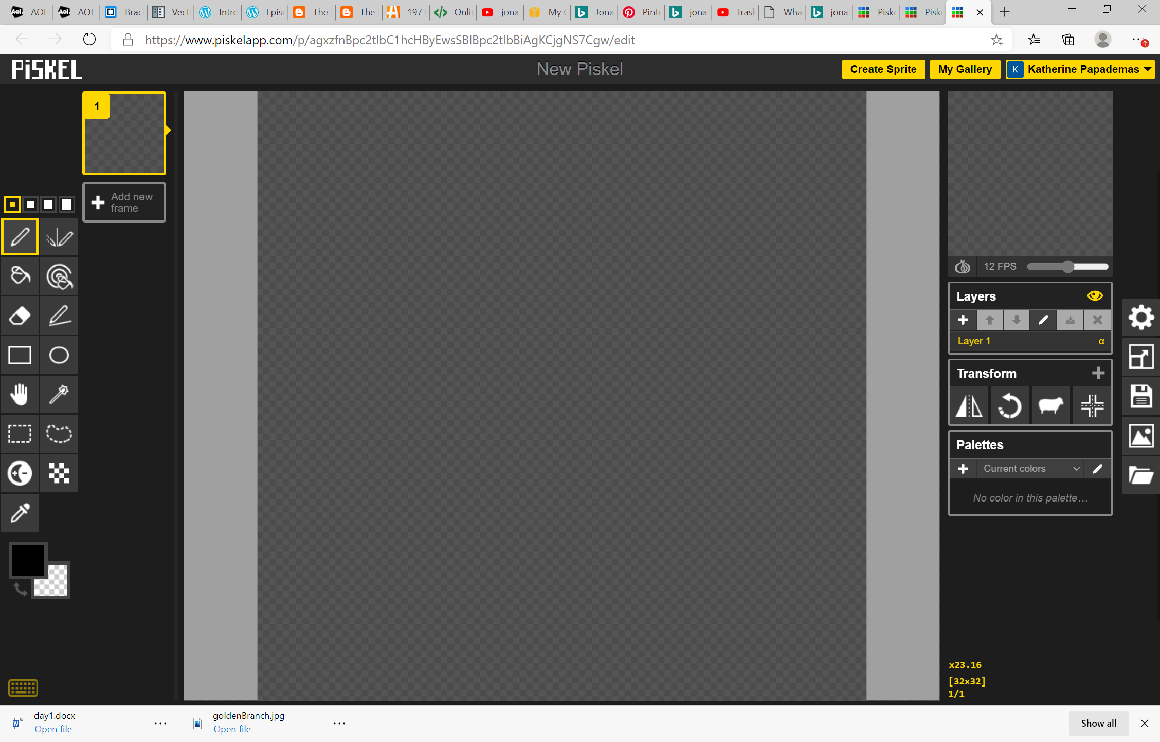

1. Familiarize with the tools on the left panel and the options on right pane .
2. Save the sprite:

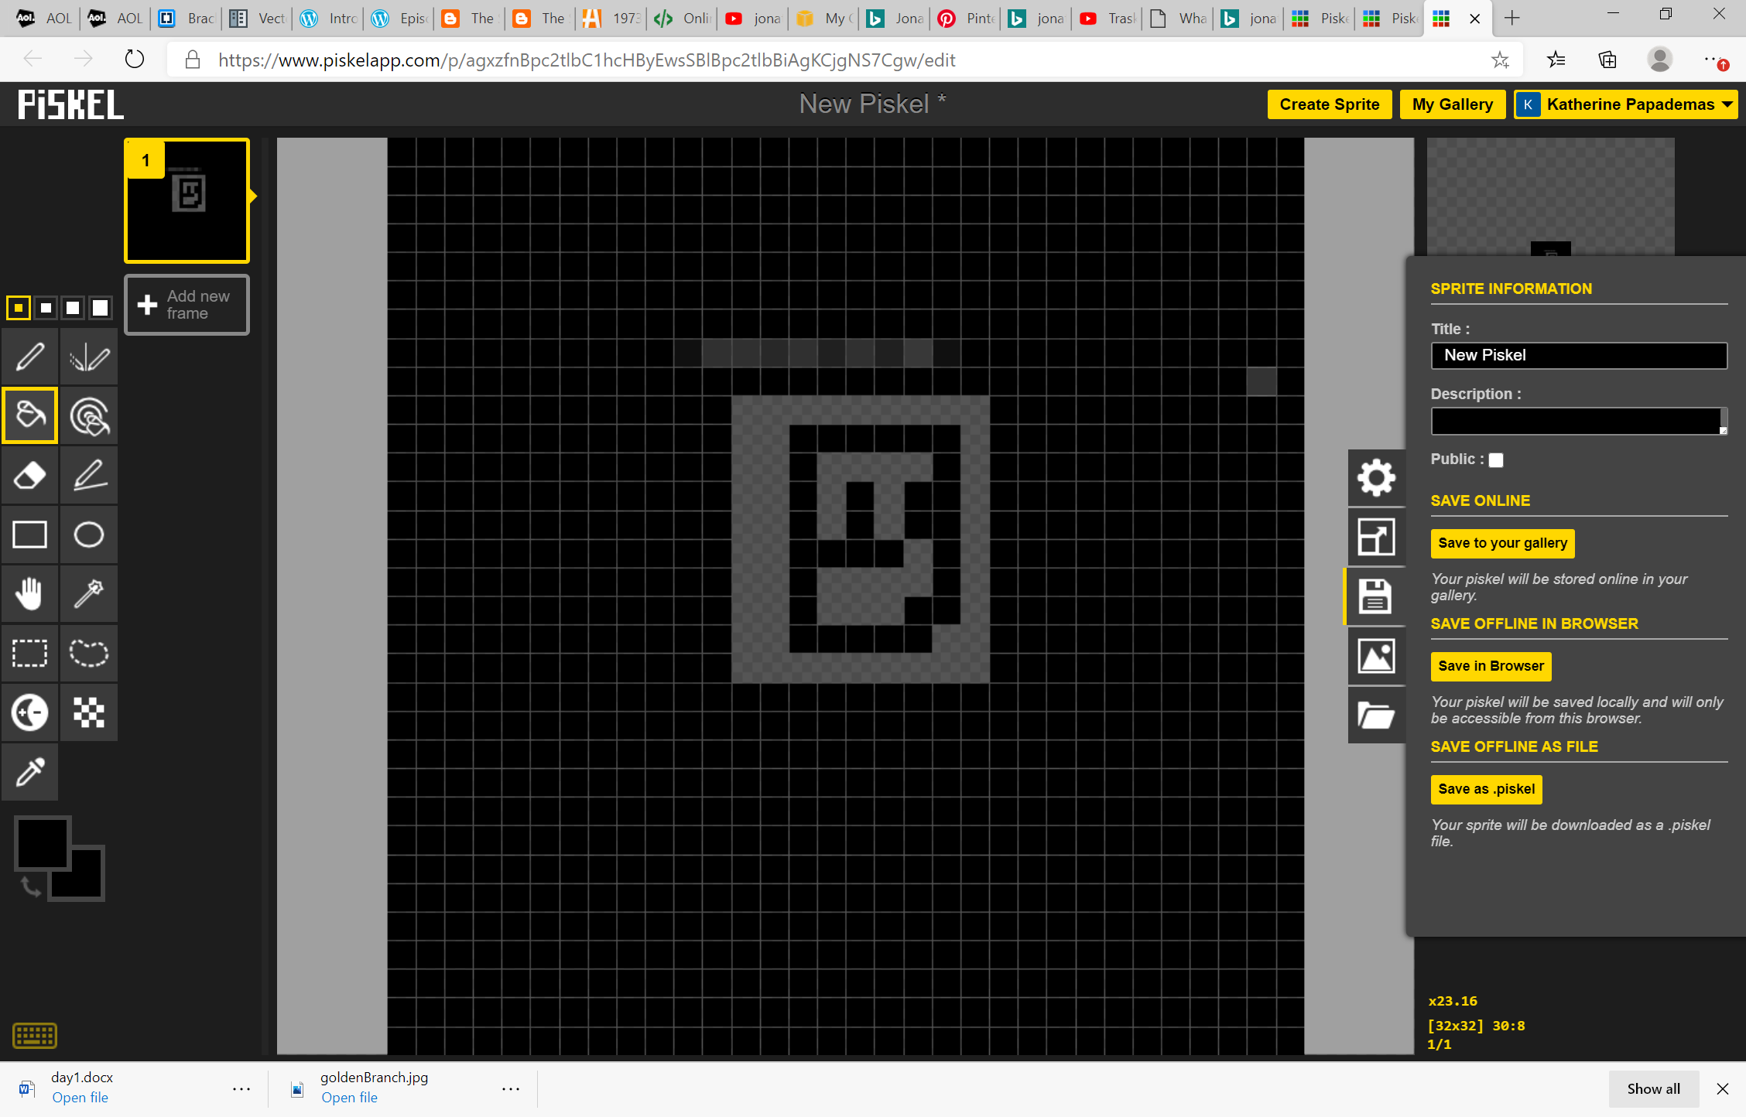

1. Creating a pallete of colors

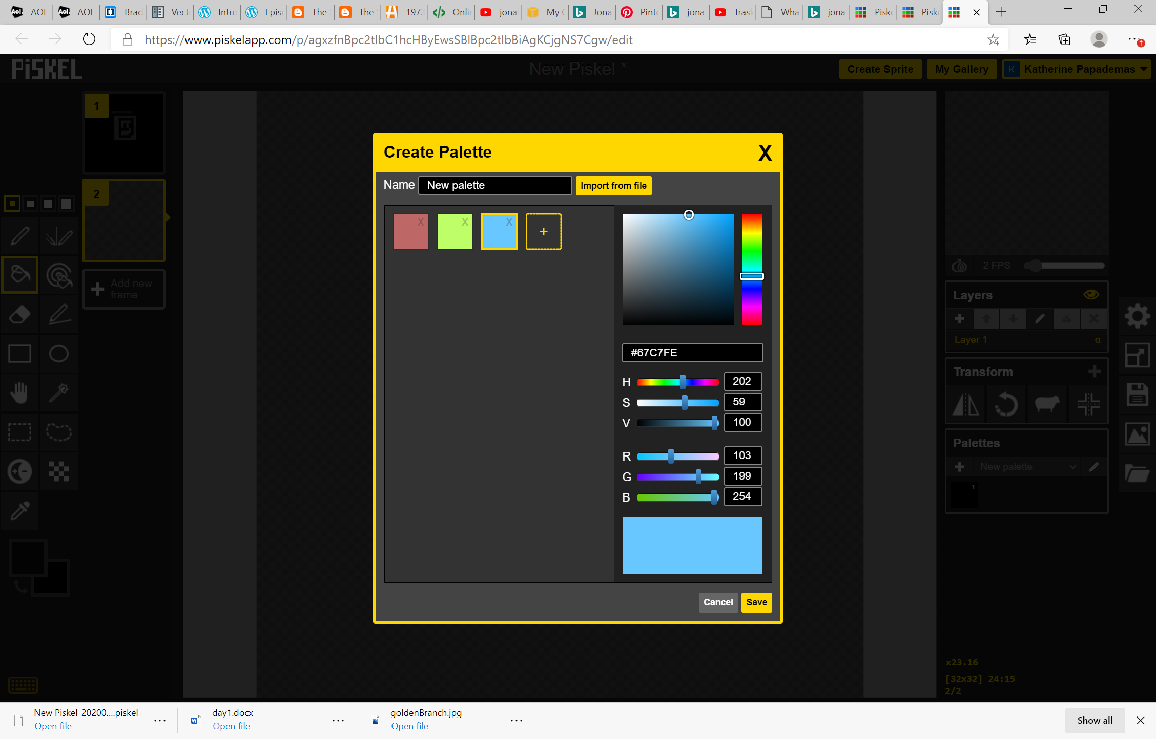

HSV -> Hue Saturation Value

RGB -> Red Green Blue 255 255 255 = white 0 0 0 = black

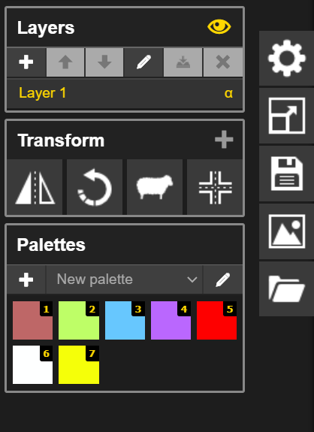

1. Layering

====

<https://sketch.io/sketchpad/>

